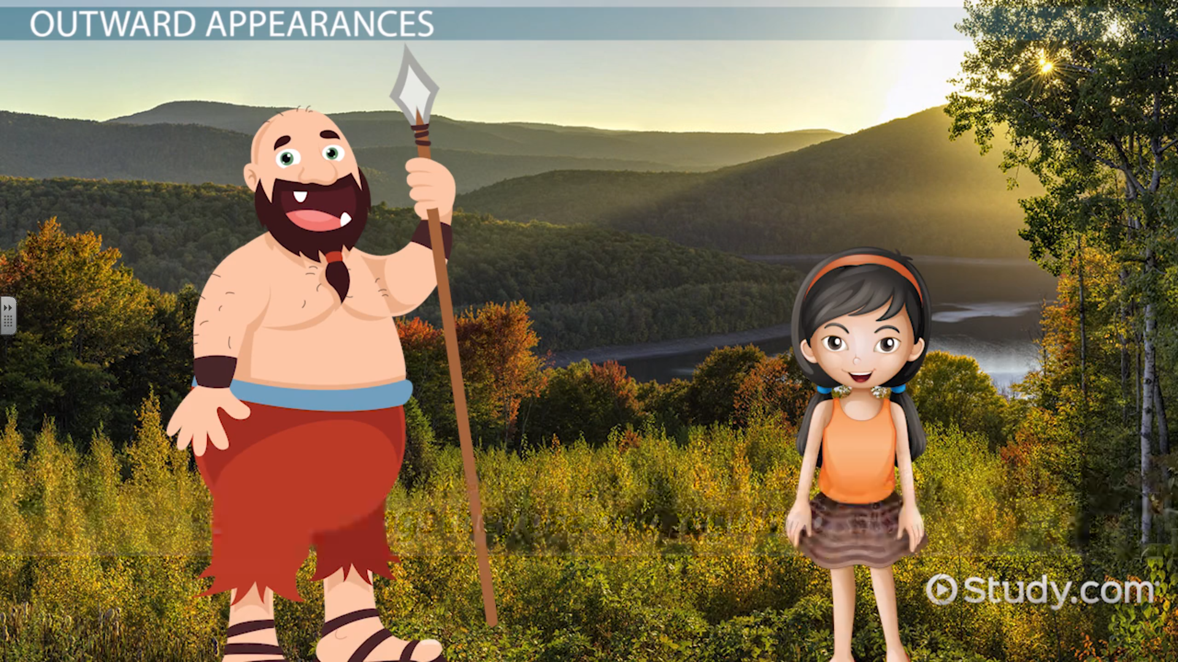
Can you describe the giant? Don’t forget to use adjectives.

