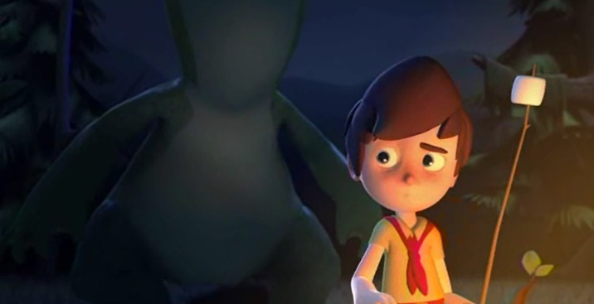
___________________________________________________  ___________________________________________________ | ___________________________________________________  ___________________________________________________ | ___________________________________________________  ___________________________________________________
___________________________________________________  ___________________________________________________ | ___________________________________________________  ___________________________________________________ | ___________________________________________________  ___________________________________________________

Draw pictures and add sentences under each picture to tell the story of Marshmallow.
Now write what you think happened next in the story. Include descriptive words and choose different ways to open your sentences.

_______________________________________________________________________________________________________

_______________________________________________________________________________________________________

_______________________________________________________________________________________________________

_______________________________________________________________________________________________________

