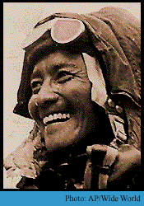
Tenzing Norgay (May 29, 1914 – May 9, 1986) was a Sherpa climber. Norgay and Sir Edmund Hillary were the first people to reach the top of Mount Everest on May 29, 1953. Norgay was born in Kharta Valley, Nepal. He died aged 71 in Darjeeling, India.

Early Life
There are different views about his early life. It is believed that he was a Sherpa born and brought up in Khumbu in Nepal. However more recent research has led to the claim that he was born a Tibetan in Kharta valley, Tibet, Khumbu lies near Mount Everest, which the Tibetans and Sherpas call Chomolungma which in Tibetan means Mother Goddess of the Earth. His exact date of birth is not known, but he knew it was in late May by the weather and the crops. After his ascent of Everest on 29 May, he decided to celebrate his birthday on that day thereafter.
He was originally called "Namgyal Wangdi", but as a child his name was changed to Tenzing Norgay which translates as "wealthy-fortunate-follower-of-religion." His father, a yak herder, was Ghang La Mingma and his mother was Dokmo Kinzom (who lived to see him climb Everest); he was the 11th of 13 children, most of whom died young.
He ran away from home twice in his teens, first to Kathmandu and later Darjeeling, and, at age 19, eventually settled in the Sherpa community in Too Song Bhusti in Darjeeling, West Bengal, India.

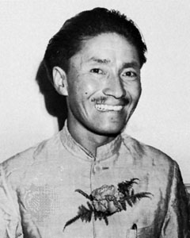
Journeys
Tenzing Norgay has been on several attempts to reach the top of Mount Everest. Two of the attempts were stopped by bad weather which caused them to turn around. One of failed attempts was in 1935 with Eric Shipton. Eventually, after 6 failure attempts, Norgay finally reached the top of Mount Everest in 1953 along with Sir Edmund Hillary. They came back down from the top of the mountain on May 29, 1953.

After Mount Everest
Tenzing later became director of field training for the Himalayan Mountaineering Institute in Darjeeling. In 1978 he started Tenzing Norgay Adventures, a company providing trekking adventures in the Himalaya.
As of 2003 the company was run by his son Jamling Tenzing Norgay, who himself reached the summit of Everest in 1996.
He was honored with the prestigious Padma Bhushan, India's third highest civilian honour, in 1959.
The Government of India instituted the Tenzing Norgay National Adventure Awards in his honour, awarded annually.

Death
Tenzing Norgay died on 9 May 1986.

