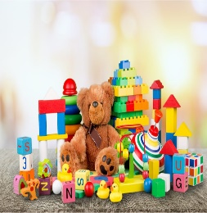
Year 1 Home Learning Activities
Wednesday 6th January 2021
Happy New Year! This term, our topic is all about toys! We can’t wait to see your hard work. Please send work to your class email account, which will be checked daily.

English
WALT: Speak clearly, with volume and clarity.

Choose a favourite toy to tell your grown-up about. Use the 5Ws hand attached to the blog to help you think of information to give about your toy. Ask your grown-up to write all of your information down for you. Finish it off with a beautiful drawing of your toy.

Maths
Mental/Oral Starter: Practise counting in 2s to 20. Can you go past 20?

WALT: add numbers

Watch this video;
https://vimeo.com/466112329

Have a go at the sheet I have attached to the blog.
Phonics
Watch this video- https://www.youtube.com/watch?v=Jf2dx5IbeZE
Can you write a list of ‘ar’ words?

Reading
Read your school reading book to a grown-up or older brother or sister. Remember we are trying to sound out in our heads to help us to read more fluently.
Don’t forget to access your books on Active Learn as well.

Science
Our Science topic this term is ‘The Human Body.’
Visit this webpage- https://www.bbc.co.uk/bitesize/topics/z9yycdm/articles/zqhbr82
Watch the video, match the labels and complete the quiz. Can you get 5 out of 5?!

Have a go at labelling body parts on the sheet I have attached to the blog.

Handwriting
If you would like to practise your handwriting, this is a fantastic website- https://www.doorwayonline.org.uk/activities/letterformation/

Next week, we will be starting live lessons on Microsoft Teams! Keep checking your email address that was sent to you on Class Charts.

