Spellings – Please complete the work below.

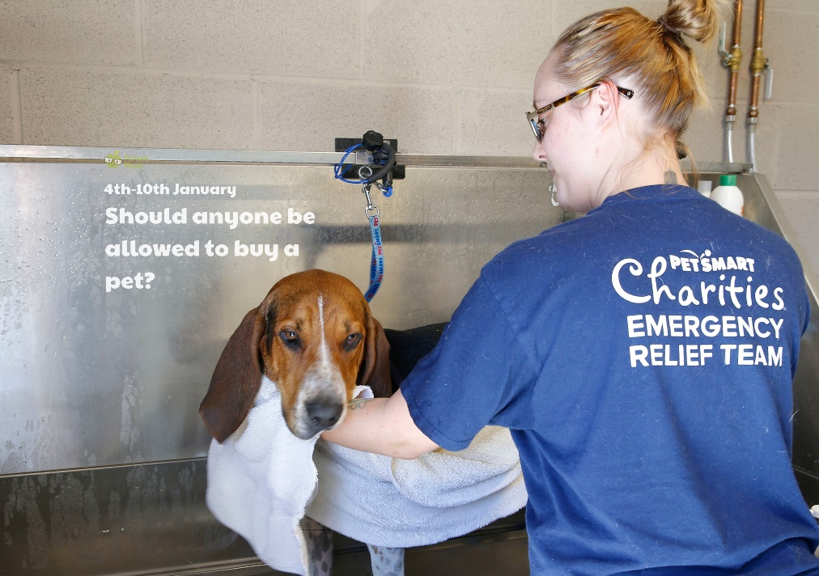
Friday -

Should anyone be able to buy a pet?
It is thought that there have been many people feeling lonelier during recent lockdown periods, particularly elderly people and those who live on their own. Vet and author Dr Muller says the companionship of a pet can offer a solution to this, “It’s not only the unconditional love pets offer but the feeling somebody accepts us for who we are and not how people want to see us.”
Research by pet food company Natures Menu has found almost one in three of new owners regret buying their pet during the first lockdown and Battersea Dogs and Cats Home predicts the number of dogs looking for new homes over the next five years could increase by around 27%.
Things to talk about at home…
Do you have any pets?
If you do, do you enjoy being a pet owner?
How do you take care of your pet?
Is it a lot of work? If not, would you like to own a pet?
Why do you think lots of people may have bought pets at the start of the lockdown period?
Do you think that there should be age restrictions or other rules on who can buy pets?
Create a wanted poster for the perfect pet owner. What things do owners of pets need to think about and do.

