Chilli Challenge:

**Mild** - Write the number to show the correct order.

**Medium** – Write a small description to show what’s happening

**Hot** – Use an adjective, an adverb and a simile in your description.

I have done the first one for you!

Tuesday 12th January 2021

WALT: Sequence a fairy tale.

BLP: Noticing

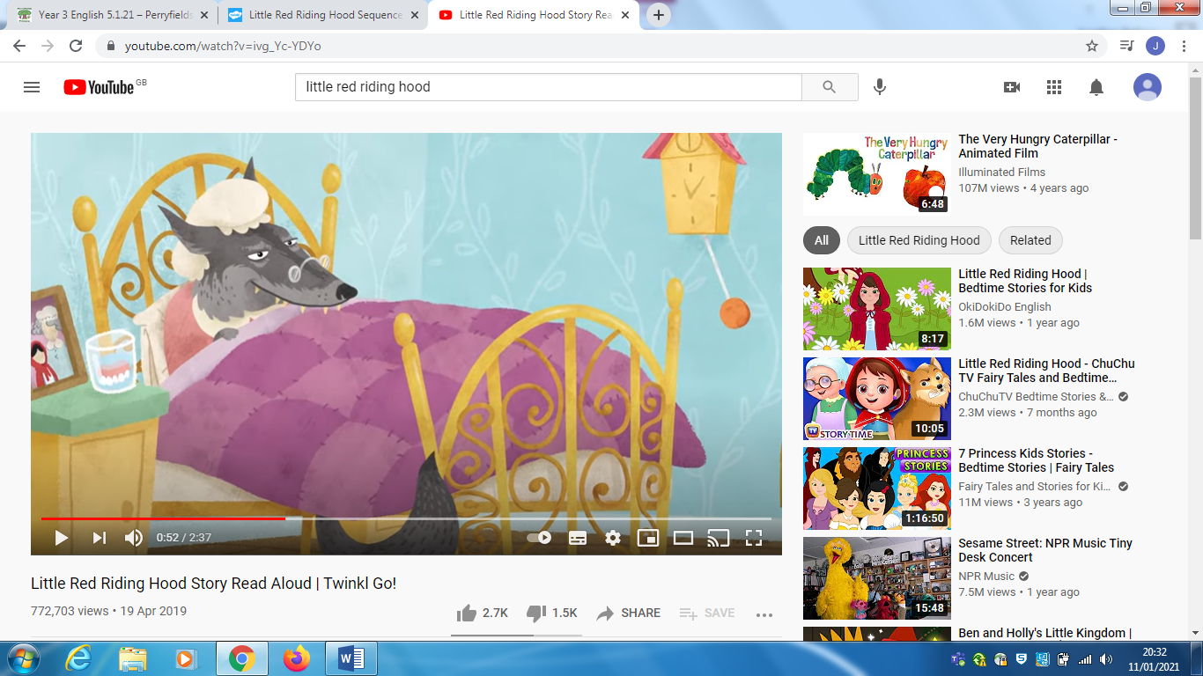

Number 3

The wolf snook into grandmas house and hid her in the wardrobe. He put her pyjamas and glasses on and pretended to be her and got into bed.

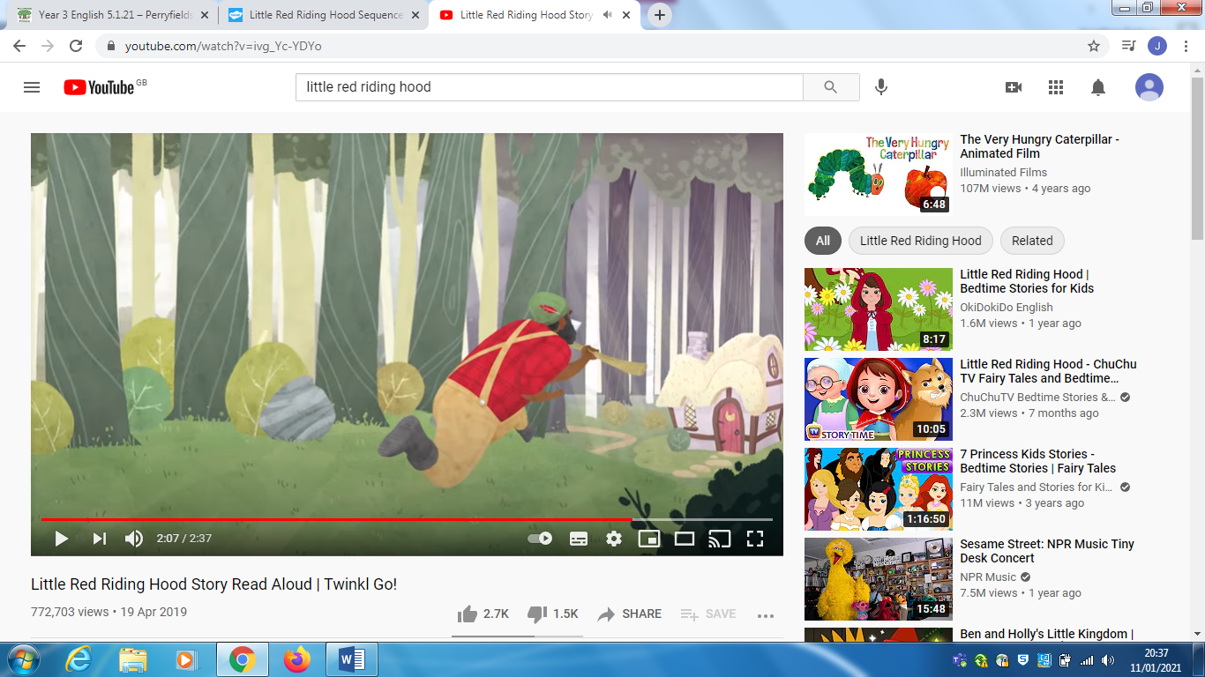

Number 6

The wood cutter heard Little red riding hood scream and went to grandmas house to see what was wrong.

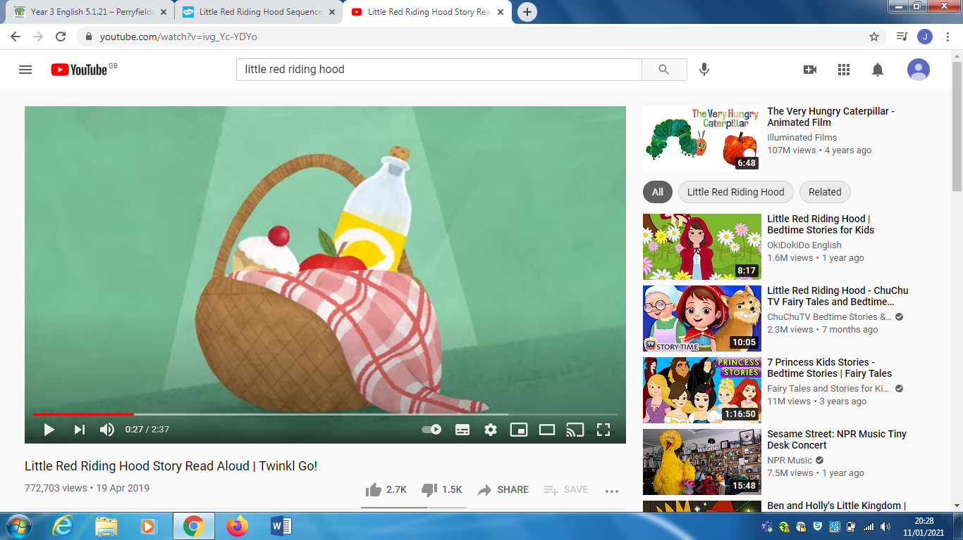

Number 1

Once upon a time, a girl named Little Red Riding Hood, who was as kind as an angel, decided to visit her granny. She happily packed a basket with delicious food so that they could enjoy a delightful picnic together.

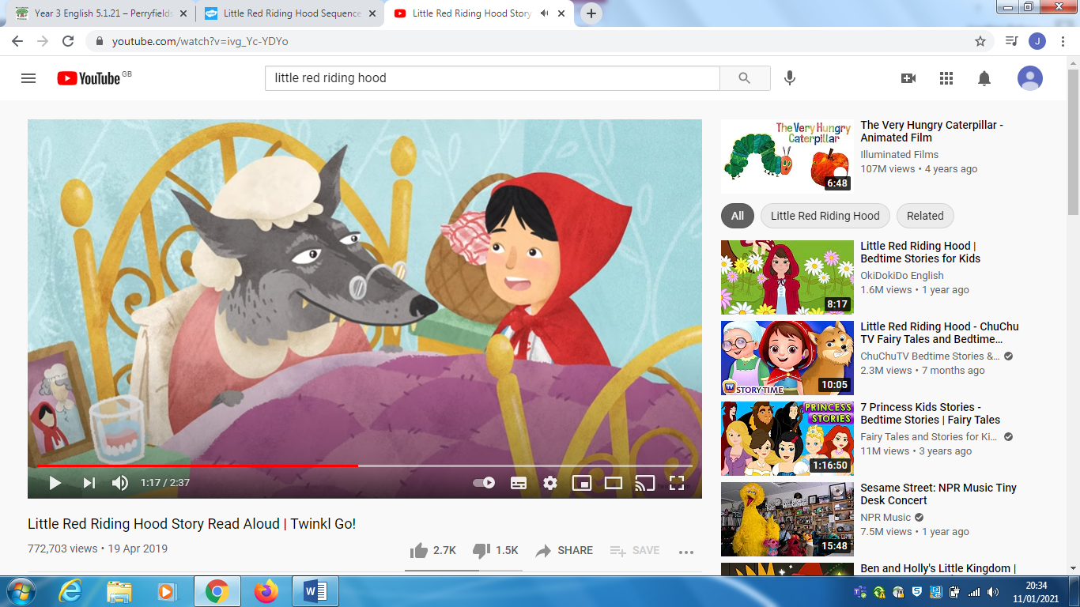

Number 4

Little red riding good arrived and seen some differences about grandma and she said “what big eyes you have grandma”

“what big ears you have grandma” and “what big teeth you have grandma”.

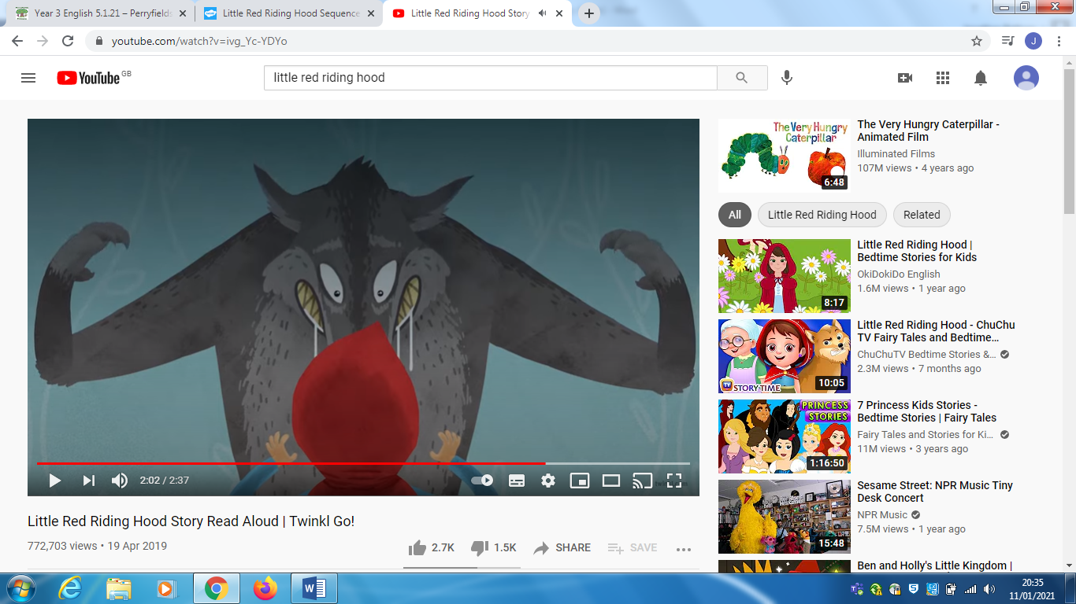

Number 5

The wolf said “ All the better to eat you with “ and climbed out of the bed .

Little red riding hood screamed .

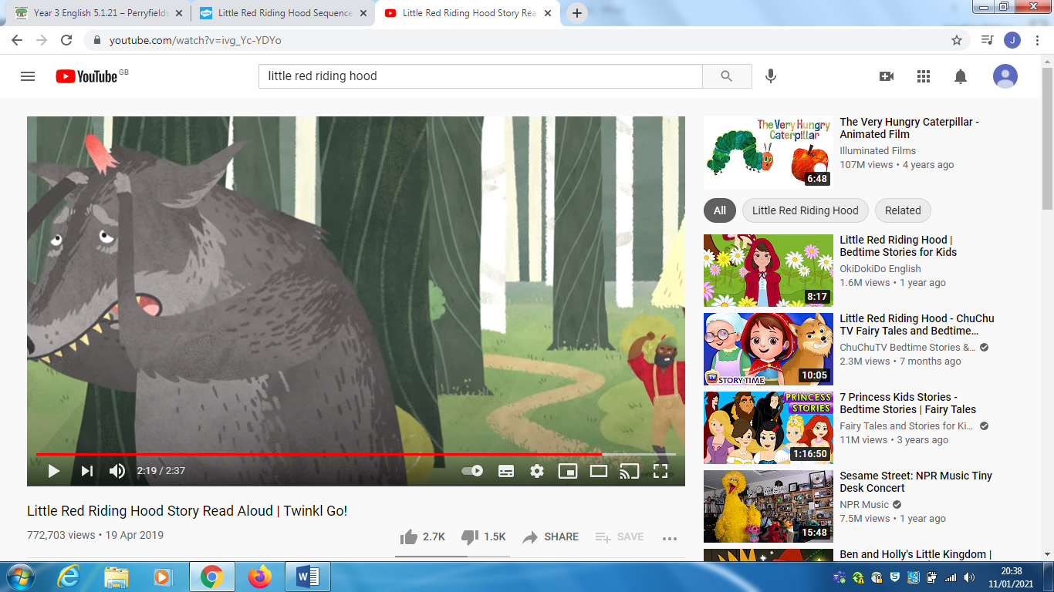

Number 7

The wood cutter seen the wolf and hit him on the head, and the wolf ran away and cried .

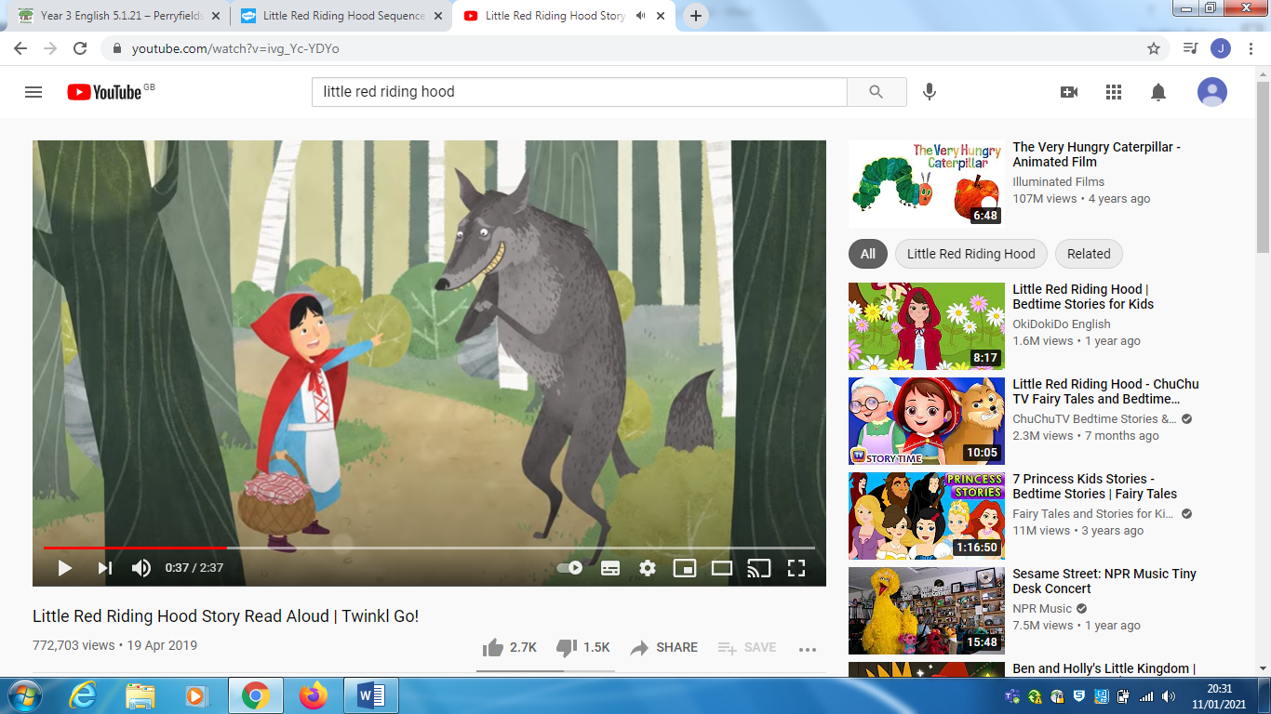

Number 2

On the way there she met a wolf, she thought the wolf was really kind , he asked her where she was going, and she told him she was going to see her grandma.

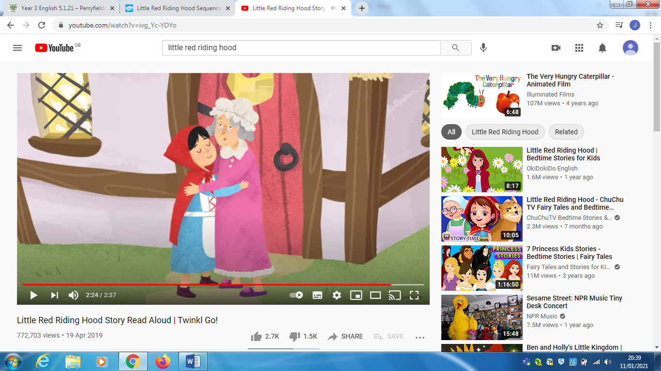

Number 8

Then she found her grandma in the wardrobe and lived happily ever after .

The end .