Tuesday 26th January
WALT: understand what can damage our teeth and how we can look after them.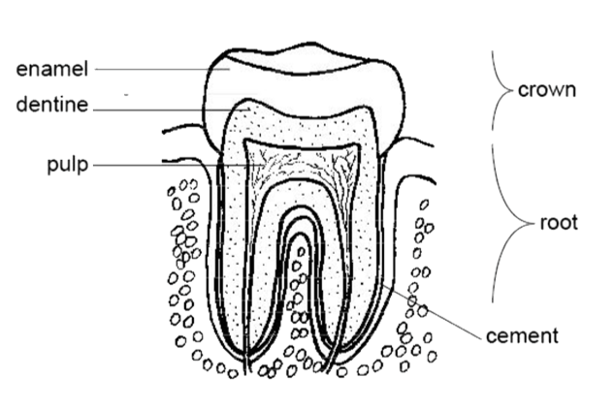
Which part of the tooth gets damaged?

How?

Which part of the tooth feels the pain?

How do we know it is painful?

How can we look after our teeth?

