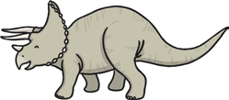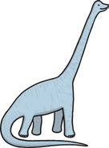

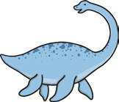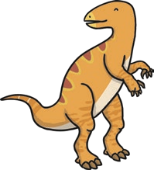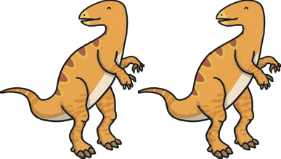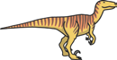

|  |  |  |  |  |  |  |
| --- | --- | --- | --- | --- | --- | --- |
|  |  |  | **+** | **2** | **=** |  |
|  | **+** | **2** | | **+** | **=** | **4** |
|  |  |  | **+** |  | **=** | **5** |
| **1** | **+** | **3** | **+** |  | **=** |  |
|  |  |  | **+** | **5** | **=** |  |