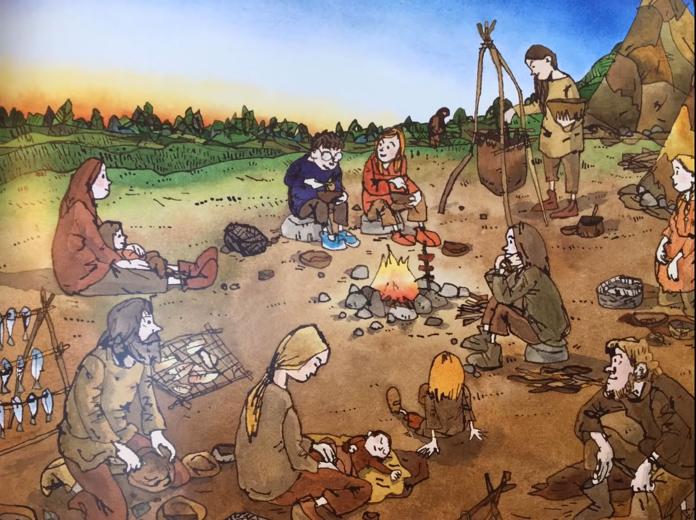
Can you write your own descriptive sentences, using adjectives, to describe the picture.

Stone Age boy is perched carefully on a smooth, grey rock munching on a piece of juicy, cooked meat.

